

# PROJECT 1 REPORT

**Yashwanth Rao Varala Balaji** – 1001916698

**Rakshith Singh Thakur** – 1002037934

I have neither given nor received unauthorized assistance on this work. I will not post the project description and the solution online.

Sign: Yashwanth Rao Varala Balaji, Rakshith Singh Thakur Date: 02/13/2023

# Part 1: File server

(Operations implemented: Yashwanth – Upload and Download, Rakshith – Rename and Delete)

XML-RPC is used to implement the file server. This remote procedure call uses HTTP transport protocol. Clients can send requests and receive a response from this server.

Run server.py file and then client.py file.

Now we will be able to choose our desired operation.

**DELETE**

Before deletion –

After Deletion –

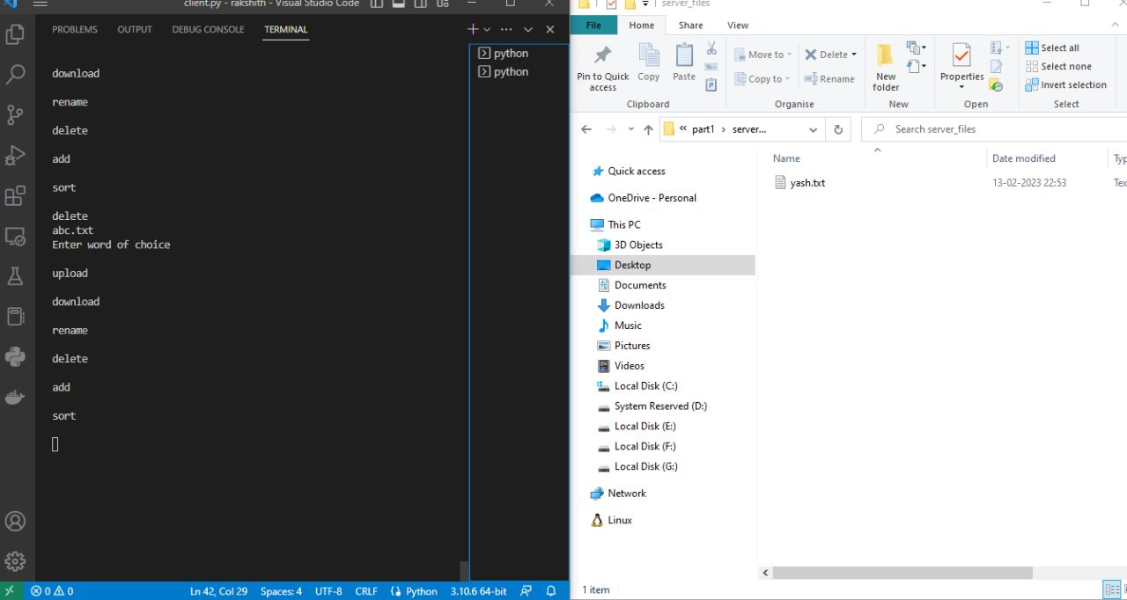

**RENAME**

Now we select the file and rename it.

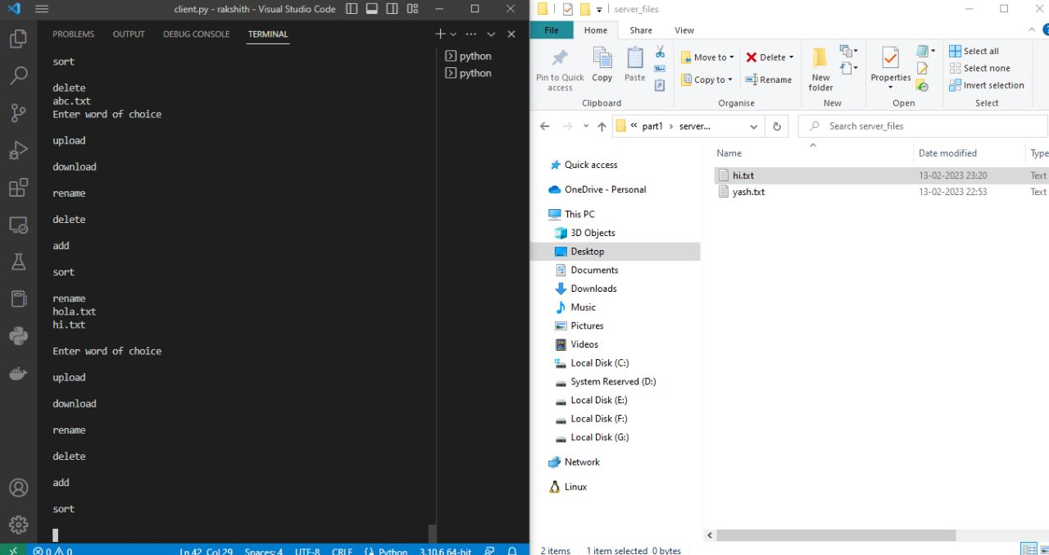

**DOWNLOAD** and **UPLOAD**

Similarly, select the download or upload option and then enter the name of the file.

Before upload-

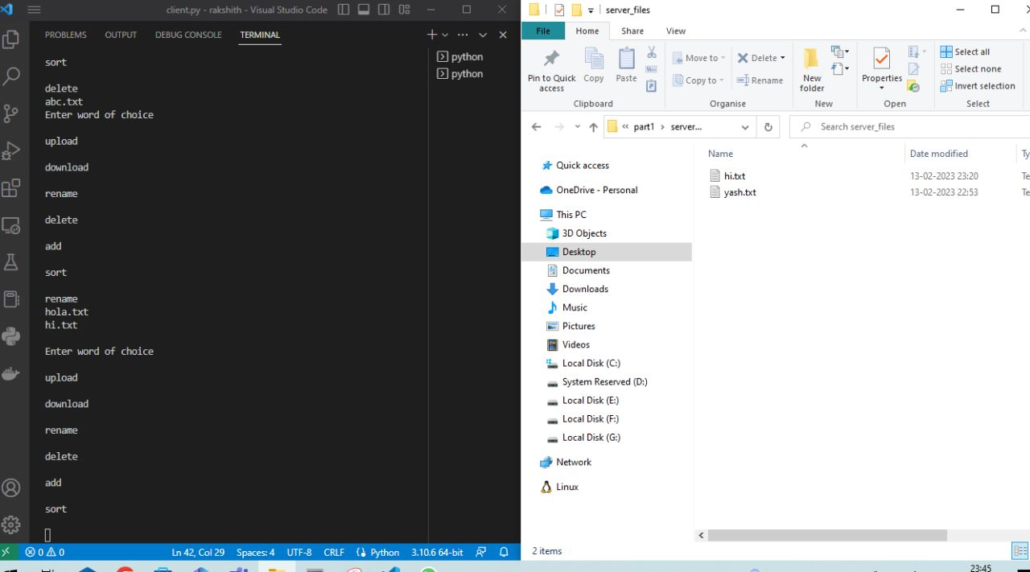

After upload –

Before Download –

After Download –

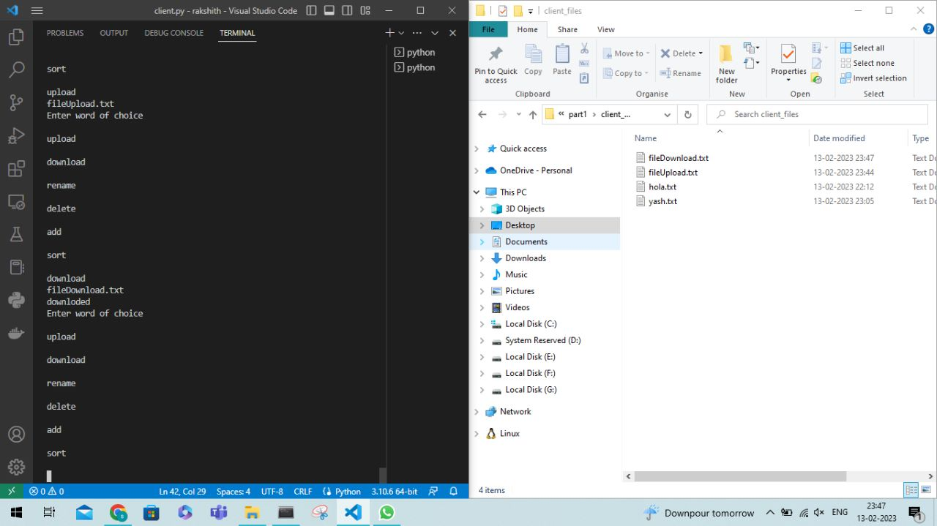

We can observe that the file uploaded from the client to the server when we choose the upload option. Also when download option is selected, the file from the server is downloaded to the client directory.

# Part 2 : Synchronized Storage Services:

(Implemented by Yashwanth and Rakshith)

We start the server again.

We check the current status of client and server directories.

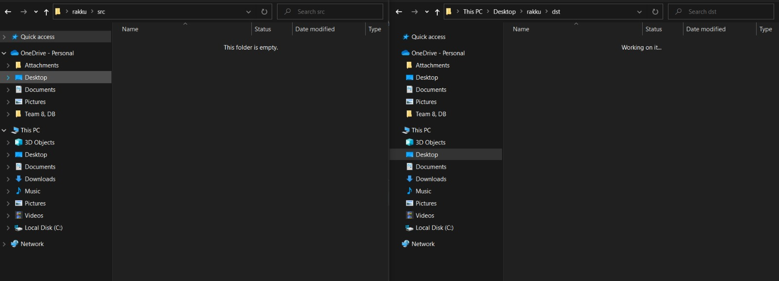

To establish storage synchronization, we will execute the rpc.py file. This file will act as a helper thread to periodically check if there are any changes made to the synchronized folder.

So, once we start the server rpc.py file is executed. We notice that the files which we created on client side are now created on the server side also.

Similarly, change in name also is synchronously made on server side.

Similarly,

If we change the name in the client directory changes are synchronously seen on server directory.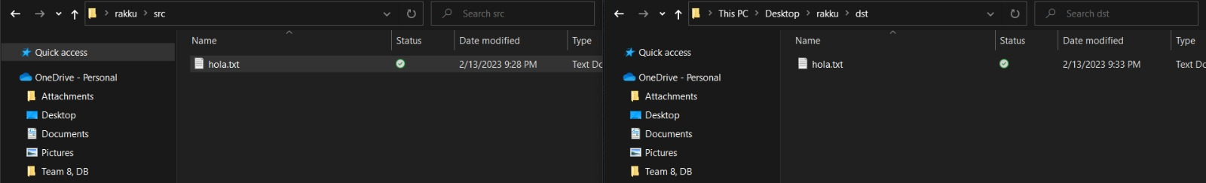

# Part 3:

# Computation on server side for ADD and SORT.

# From the options, select Add and enter the numbers to be added.

# Similarly for Sort, select sort and then enter numbers to be sorted separated by spaces.

